How to Care for Your Holiday Poinsettia

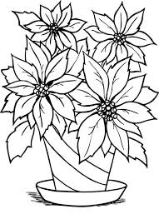
You can keep your poinsettia healthy and vigorous throughout the holiday season.
Place the poinsettia near a sunny window.
South, east, or west facing windows are preferable to a north-facing window. Poinsettias are tropical plants and so will appreciate as much direct sunlight as you can provide.
Keep the poinsettia warm. Maintain a temperature of 65 to 75 degrees Fahrenheit during the day. Dropping the temperature to about 60 degrees at night will not hurt the plant. However, cold drafts from exterior doors or allowing the leaves to touch a cold window can injure the leaves and cause premature leaf drop.

Water the plant whenever the surface of the soil feels dry to the touch. Water until it drains out the bottom of the pot. Do not let the plant sit in water in the pot cover or in a plant saucer. Do not fertilize the poinsettia when it is in bloom.

Avoid exposing the poinsettia plant to temperatures below 50*F. If you need to transport your poinsettia use a roomy shopping bag to protect the plant from cold and winds. If moving the poinsettia in a vehicle, warm the interior before putting the poinsettia in.

